Compiling model...
Training model...
Evaluating model...
13/13 [==============================] - 0s 3ms/step - loss: 0.0498 - accuracy: 0.9879
[Results]
- Test loss: 0.04982094094157219

- Test accuracy: 0.9878935217857361

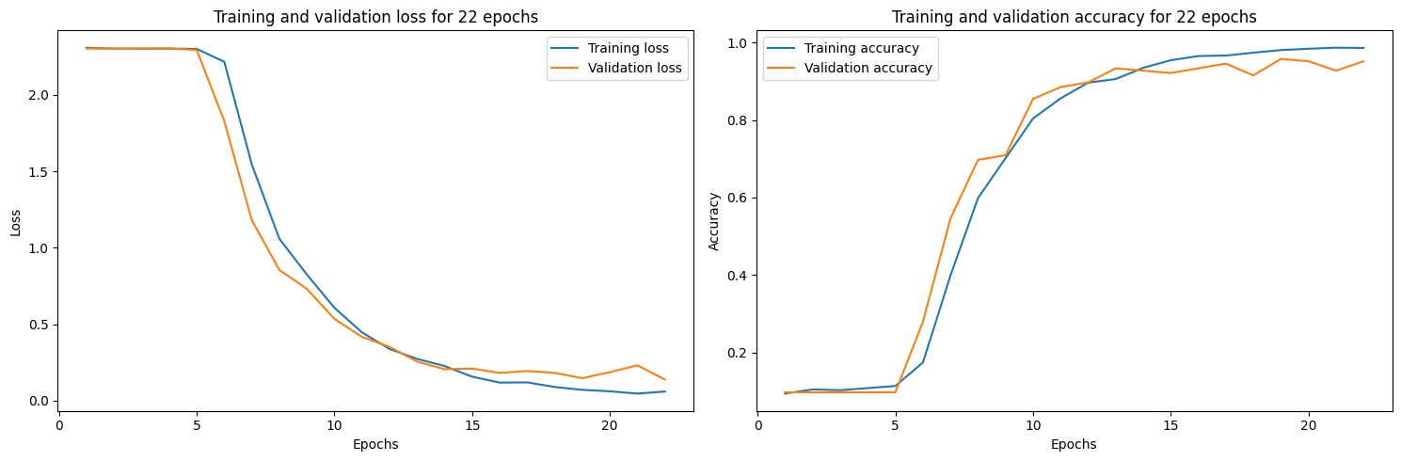
Compiling model...
Training model...
Evaluating model...
13/13 [==============================] - 0s 3ms/step - loss: 0.0498 - accuracy: 0.9879
[Results]
- Test loss: 0.04982094094157219

- Test accuracy: 0.9878935217857361

model = myCNNmodel_hard()
compile_test_model(model, rgb=False, msummary=False, epochs=22, verbose=0)

